**Name: ___________________ Class: ____ Date: _______ Mark: ____ / 25**

**Year 9 Physical Sciences**

**TASK: Analysing an Ohm’s Law Experiment**

A student conducted an experiment to measure the resistance of two different light globes using Ohm’s Law. A description of the experiment and results are given below.

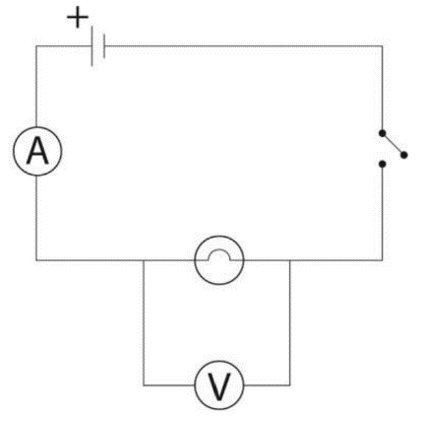“I connected the first globe and switch in series with a power pack. To measure the current through the globe, I added an ammeter in series with it. I connected a voltmeter in parallel to the globe to measure its voltage.

I set the power pack to 0 V, and recorded the voltage and current. Then I increased the voltage on the power pack to 2 V, and recorded the voltage and current again. I continued to increase the voltage by 2 V each time and repeated the measurements, until I reached 12 V.

I repeated my experiment with a different globe, to see if it had a different resistance.

Questions:

1. What was the student’s aim in this experiment? (1)

________________________________________________________________________ ________________________________________________________________________

1. For the student’s experiment, identify the: (4)
   1. Independent (changed) variable: __________________________________________
   2. Dependent (measured) variable: __________________________________________
   3. Two controlled variables: ________________________________________________

________________________________________________

1. Explain why the student connected the ammeter in series with the globe, but connected the voltmeter in parallel to the globe. (2)

________________________________________________________________________________________________________________________________________________________________________________________________________________________

The student’s results are shown in the table below. Use the results to draw a graph and answer the questions.

|  |  |  |
| --- | --- | --- |
| **Voltage (V)** | **Current of Globe 1 (A)** | **Current of Globe 2 (A)** |
| 0 | 0 | 0 |
| 2 | 5 | 8 |
| 4 | 10 | 16 |
| 6 | 15 | 24 |
| 8 | 20 | 32 |
| 10 | 25 | 4 |
| 12 | 30 | 48 |

1. Plot a **scatter** graph of voltage vs current on the grid below. Include a key and lines of best fit. (7)

|  |  |  |  |  |  |  |  |  |  |  |  |  |  |  |  |  |  |  |  |  |  |  |  |  |
| --- | --- | --- | --- | --- | --- | --- | --- | --- | --- | --- | --- | --- | --- | --- | --- | --- | --- | --- | --- | --- | --- | --- | --- | --- |
|  |  |  |  |  |  |  |  |  |  |  |  |  |  |  |  |  |  |  |  |  |  |  |  |  |
|  |  |  |  |  |  |  |  |  |  |  |  |  |  |  |  |  |  |  |  |  |  |  |  |  |
|  |  |  |  |  |  |  |  |  |  |  |  |  |  |  |  |  |  |  |  |  |  |  |  |  |
|  |  |  |  |  |  |  |  |  |  |  |  |  |  |  |  |  |  |  |  |  |  |  |  |  |
|  |  |  |  |  |  |  |  |  |  |  |  |  |  |  |  |  |  |  |  |  |  |  |  |  |
|  |  |  |  |  |  |  |  |  |  |  |  |  |  |  |  |  |  |  |  |  |  |  |  |  |
|  |  |  |  |  |  |  |  |  |  |  |  |  |  |  |  |  |  |  |  |  |  |  |  |  |
|  |  |  |  |  |  |  |  |  |  |  |  |  |  |  |  |  |  |  |  |  |  |  |  |  |
|  |  |  |  |  |  |  |  |  |  |  |  |  |  |  |  |  |  |  |  |  |  |  |  |  |
|  |  |  |  |  |  |  |  |  |  |  |  |  |  |  |  |  |  |  |  |  |  |  |  |  |
|  |  |  |  |  |  |  |  |  |  |  |  |  |  |  |  |  |  |  |  |  |  |  |  |  |
|  |  |  |  |  |  |  |  |  |  |  |  |  |  |  |  |  |  |  |  |  |  |  |  |  |
|  |  |  |  |  |  |  |  |  |  |  |  |  |  |  |  |  |  |  |  |  |  |  |  |  |
|  |  |  |  |  |  |  |  |  |  |  |  |  |  |  |  |  |  |  |  |  |  |  |  |  |
|  |  |  |  |  |  |  |  |  |  |  |  |  |  |  |  |  |  |  |  |  |  |  |  |  |
|  |  |  |  |  |  |  |  |  |  |  |  |  |  |  |  |  |  |  |  |  |  |  |  |  |
|  |  |  |  |  |  |  |  |  |  |  |  |  |  |  |  |  |  |  |  |  |  |  |  |  |
|  |  |  |  |  |  |  |  |  |  |  |  |  |  |  |  |  |  |  |  |  |  |  |  |  |
|  |  |  |  |  |  |  |  |  |  |  |  |  |  |  |  |  |  |  |  |  |  |  |  |  |
|  |  |  |  |  |  |  |  |  |  |  |  |  |  |  |  |  |  |  |  |  |  |  |  |  |
|  |  |  |  |  |  |  |  |  |  |  |  |  |  |  |  |  |  |  |  |  |  |  |  |  |
|  |  |  |  |  |  |  |  |  |  |  |  |  |  |  |  |  |  |  |  |  |  |  |  |  |
|  |  |  |  |  |  |  |  |  |  |  |  |  |  |  |  |  |  |  |  |  |  |  |  |  |
|  |  |  |  |  |  |  |  |  |  |  |  |  |  |  |  |  |  |  |  |  |  |  |  |  |
|  |  |  |  |  |  |  |  |  |  |  |  |  |  |  |  |  |  |  |  |  |  |  |  |  |

1. An outlier is a data point that does not seem to fit the pattern of the rest of the data.
   1. Which of the student’s data points is most likely an outlier? (1)

________________________________________________________________________________________________________________________________________

* 1. Based on the table or your graph, predict what this value should have been, if it followed the same pattern as the rest of the data. (1)

_____________________________________________________________________

* 1. Propose what may have caused this incorrect measurement. (1)

____________________________________________________________________________________________________________________________________________________________________________________________________________

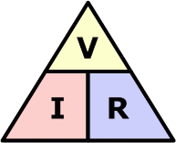

1. The student wants to calculate the resistance of each globe. Write down the equation they should use. (1)
2. Use a pair of values from the table and Ohm’s law to calculate the resistance of each of the two globes.

Globe 1: (3)

|  |  |  |
| --- | --- | --- |
| **Given** | **Work** | **Final Answer** |
|  |  |  |

Globe 2: (3)

|  |  |  |
| --- | --- | --- |
| **Given** | **Work** | **Final Answer** |
|  |  |  |

1. What conclusion can the student make about the effect of resistance on the current flowing through a circuit? (1)

________________________________________________________________________________________________________________________________________________________________________________________________________________________